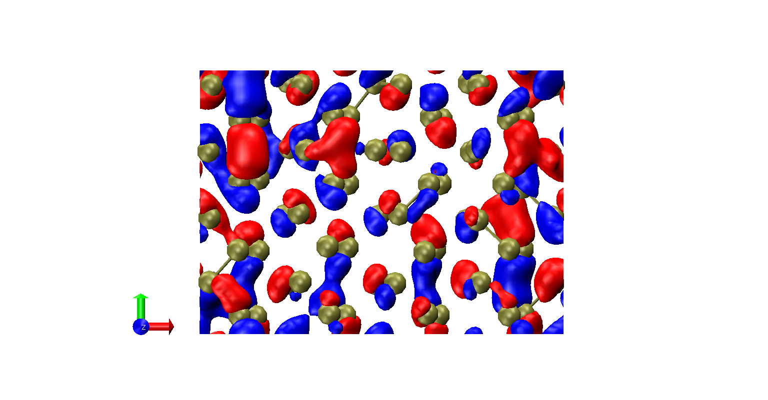 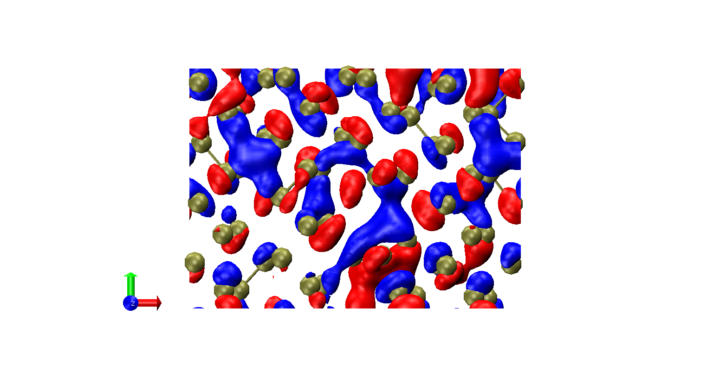

(a) (b)

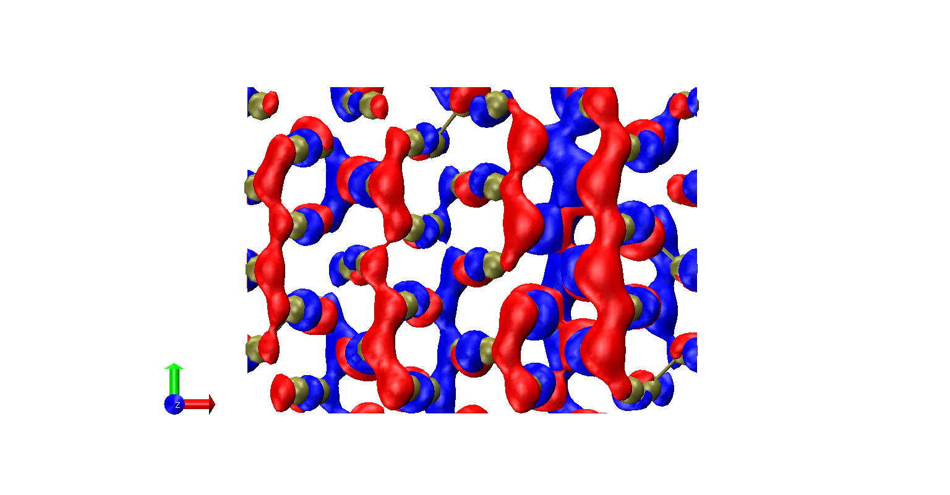 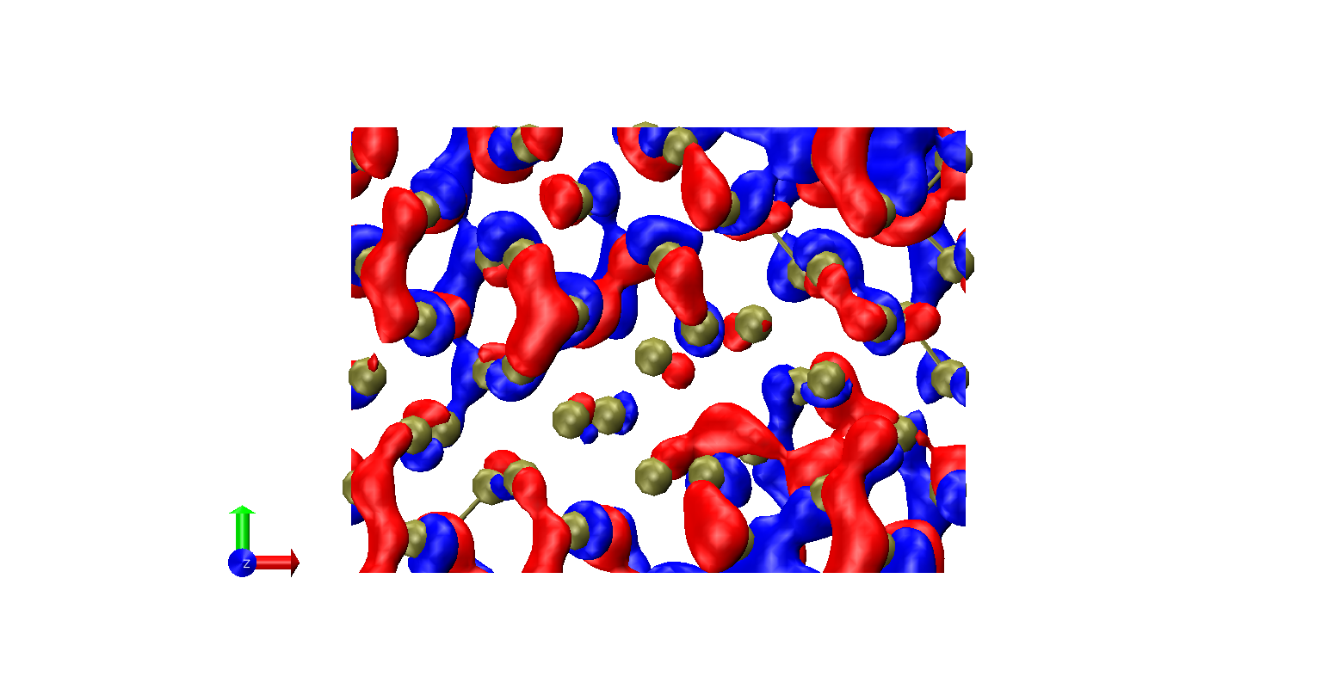

(c) (d)

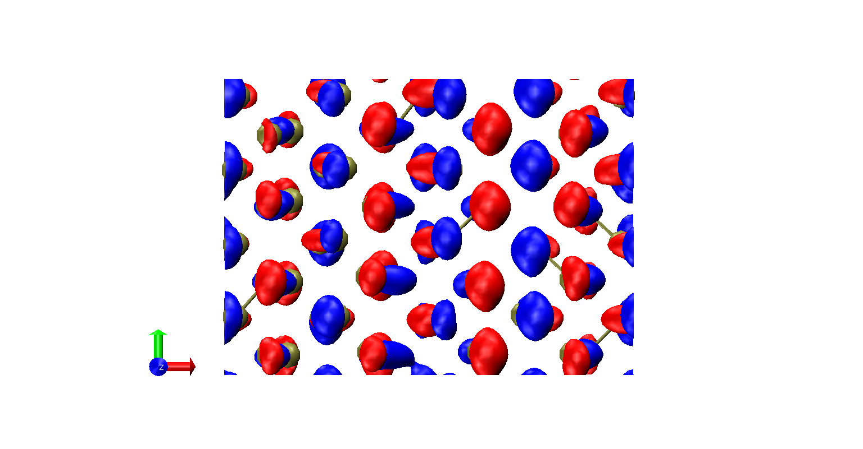 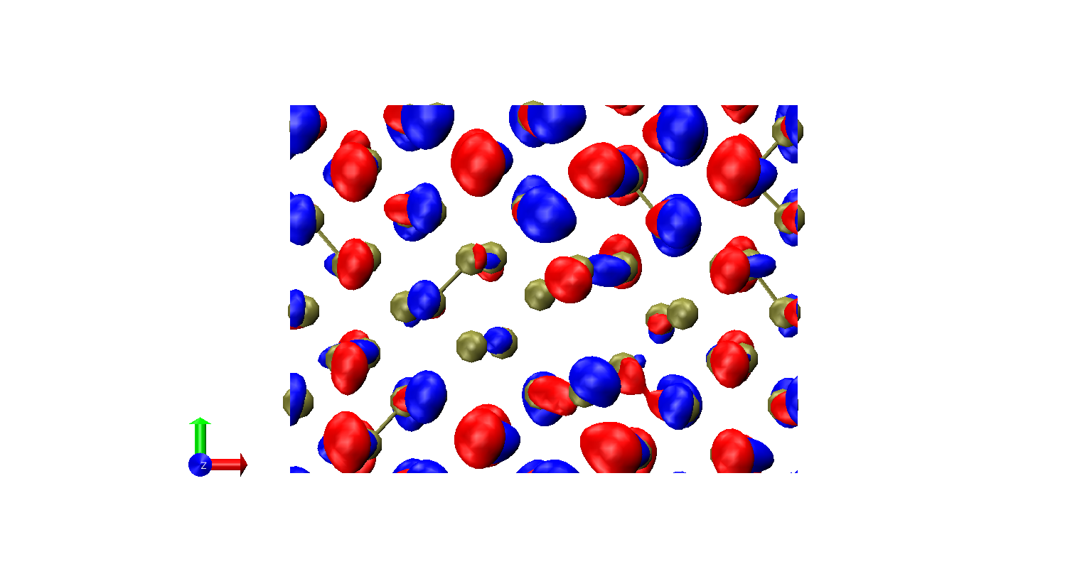

(e) (f)

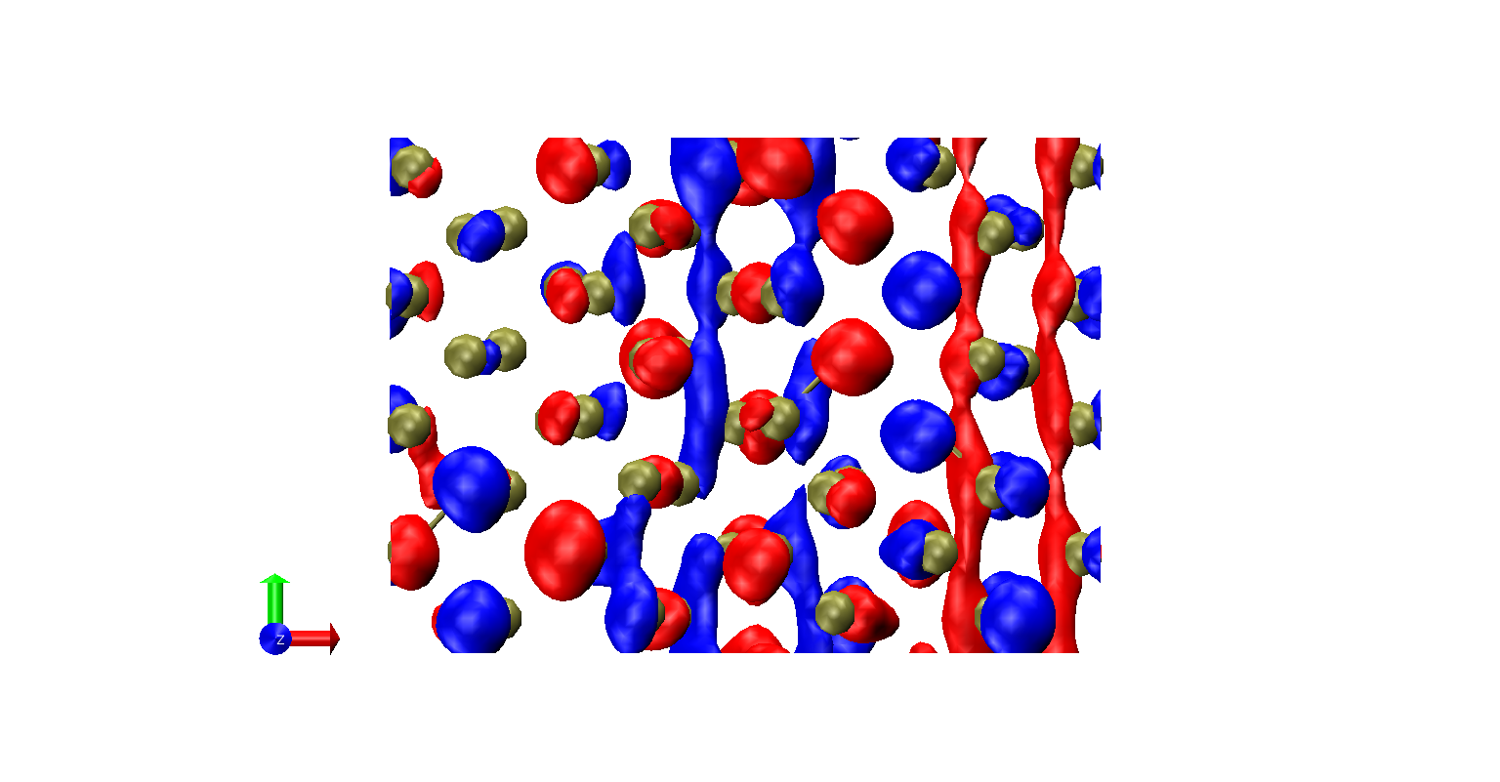 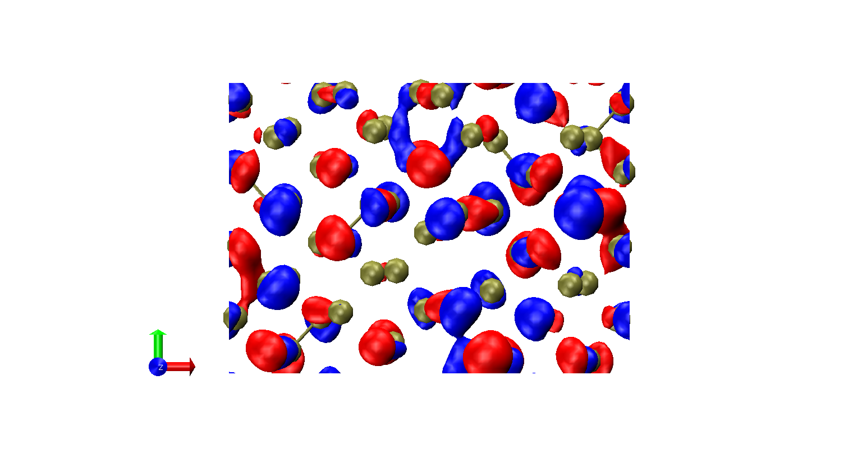

(g) (h)

**Figure 1.** Orbitals of the pristine (left column, a, c, e, g) and divacancy-containing (right column, b, d, f, h) phosphorene: LUMO+1 (a, b), LUMO (c, d), HOMO (e, f), HOMO-1 (g, h). Orbital isosurface values are are +/- 0.015 a.u.-3 (blue – negative, red - positive). Phosphorus atoms are shown in tan color. Axes: red is the zigzag direction, green – is the armchair direction. Calculations are conducted using Hubbard parameter of 1.37 eV (note that the suggested values for CP2k are to be 2-3 times smaller than those for QE).